Combining Networks- Union and Intersection

From the Project landing page you can add together or fing the intersection(overlap) of Networks in your project. Just click the check boxes to the left of the Networks that you wish to combine.

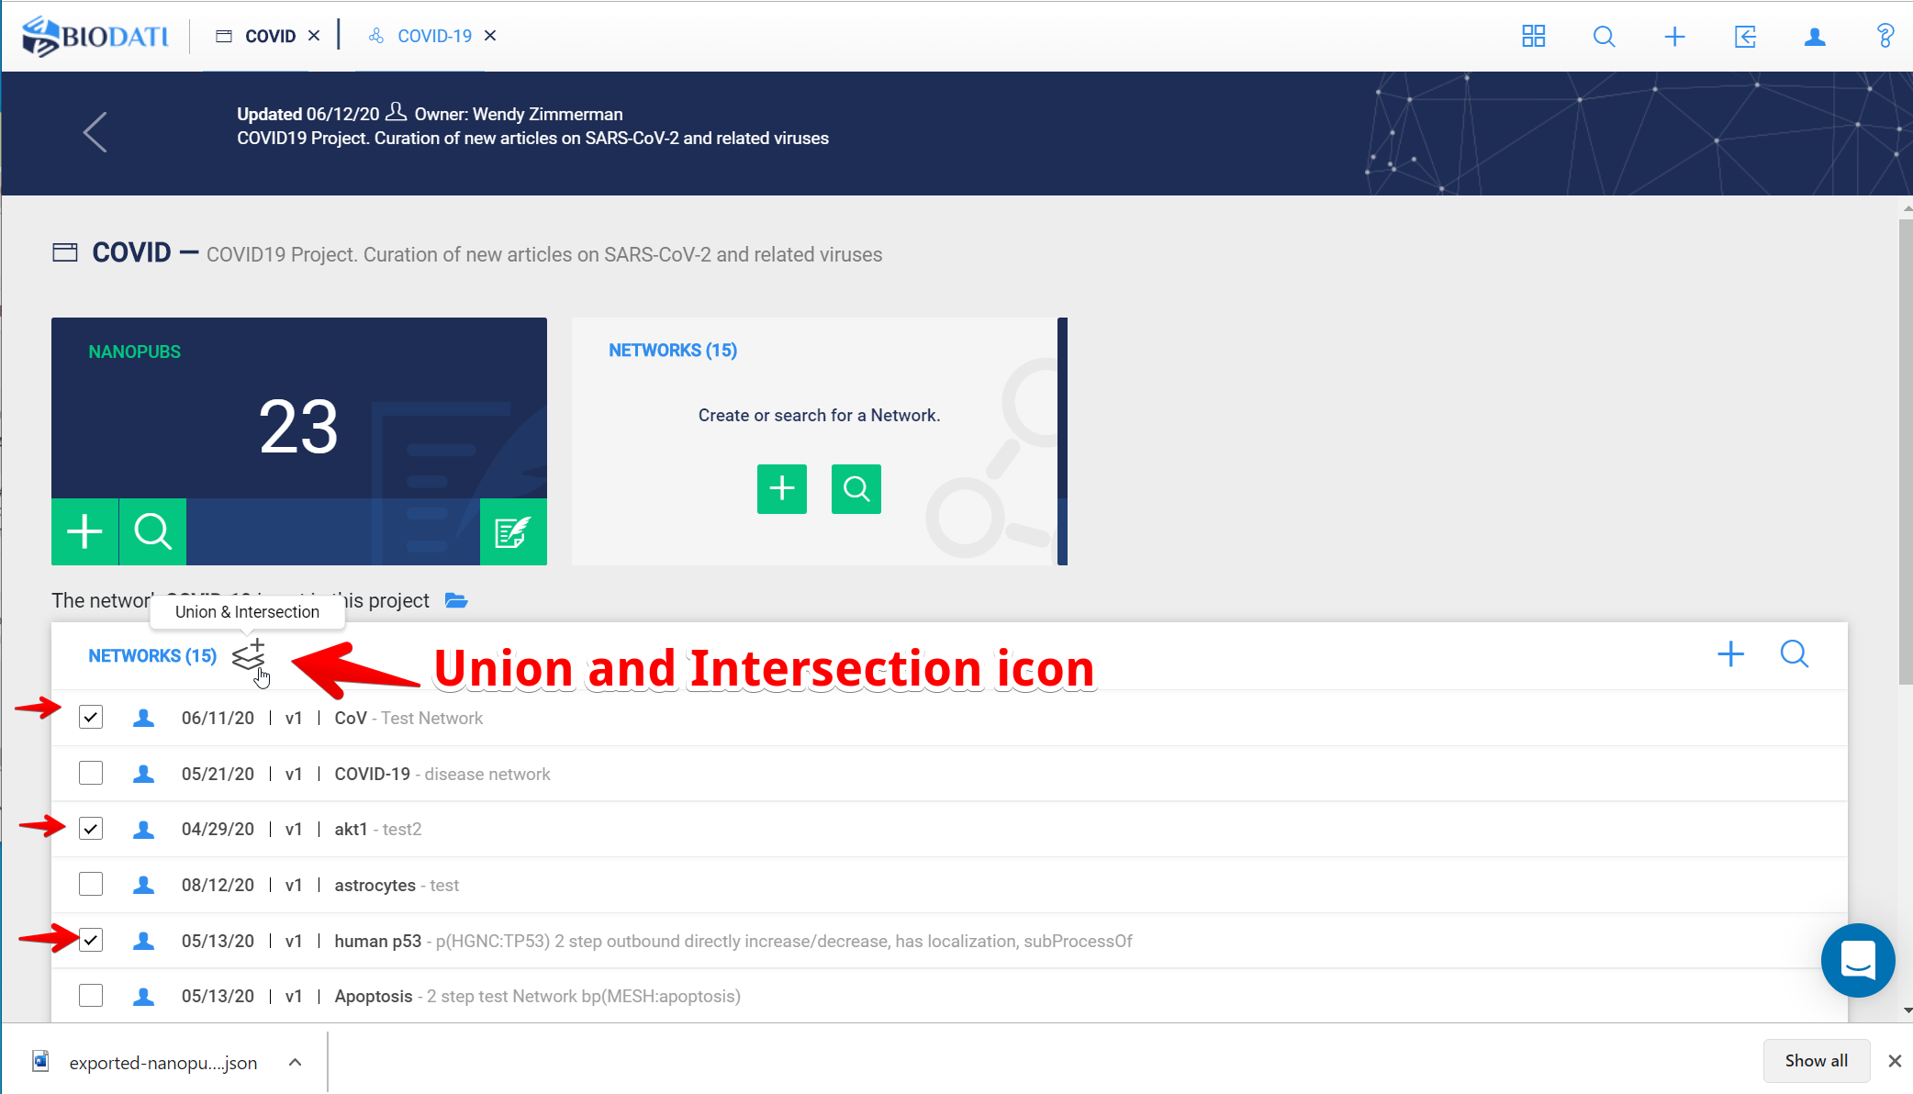

The union and intersection dialogue box will open, Click union or intersection,

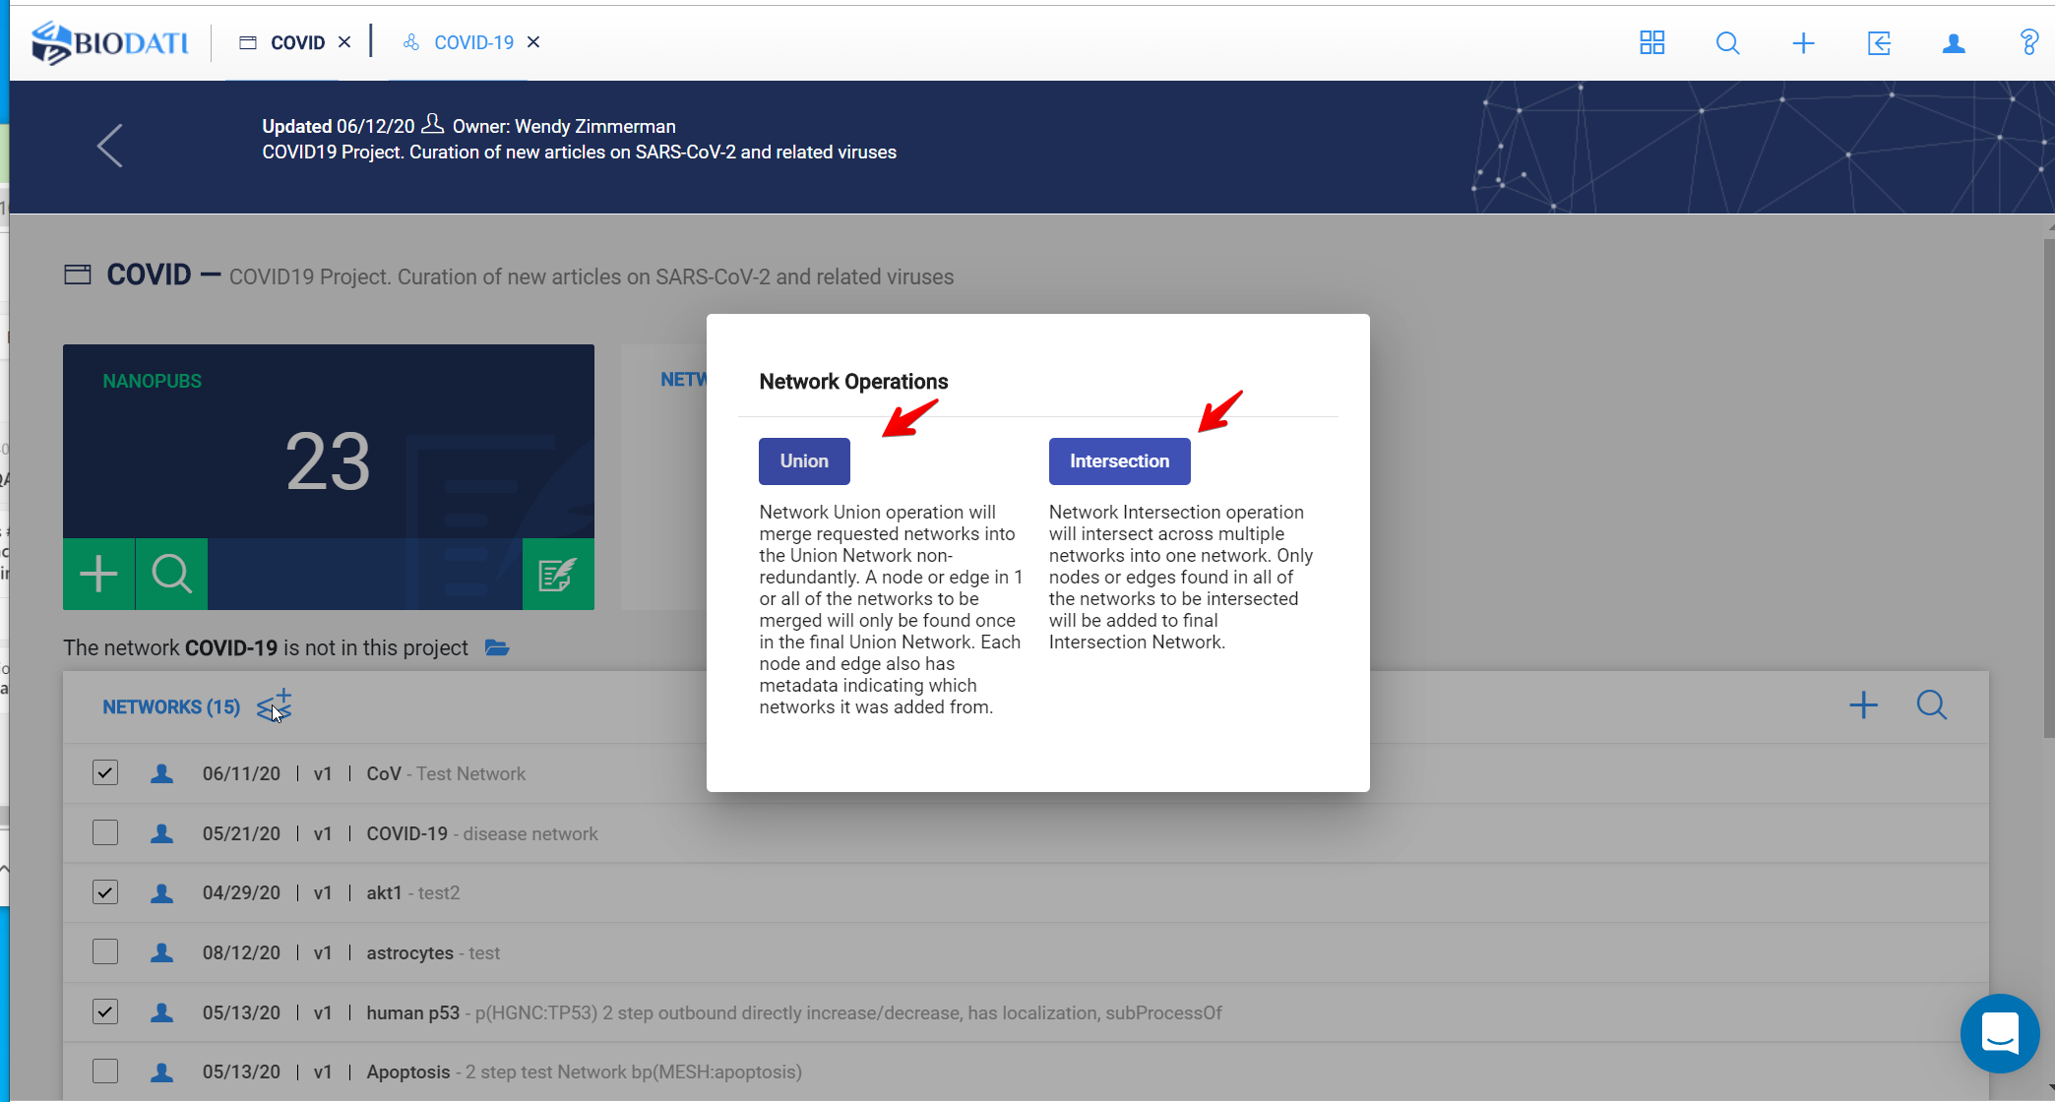

Your new Network will appear at the bottom of your Network list.

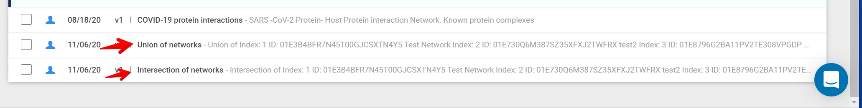

You can edit the Network name and description as desired, y clicking “Edit Network Information” on the Network landing page.